Field uniformity:

# Metric:

Following “Evaluation of illumination system uniformity for wide-field biomedical hyperspectral imaging”, Travis W Sawyer et al 2017 J. Opt.19 045301

Ranges from 0 to 1, 0 is perfectly uniform distribution

is the standard deviation of the distribution and is the mean value. Perfect uniform illumination is represented by the 0 value

# Case 1: Before

Light guide tip position versus collector lens adjusted to image the tip at the condenser diaphragm following the ”Proper alignment and adjustment of the light microscope” guide. The frosted glass tube holder is in place between the collector lens and the condenser.

Image acquisition at 550nm (BW 10nm) and broadband

Camera shutter time: 550 nm = 0.4 ms; BB = 0.14 ms

# Case 1: After

Integrating sphere between the light guide tip and the collector lens. The tuning of the collector lens position obtained previously is kept. The frosted glass tube holder is in place between the collector lens and the condenser.

Image acquisition at 550nm (BW 10nm) and broadband

Camera shutter time: 550 nm = 21 ms; BB = 6 ms

BB

550 nm

Before

After

Before

After

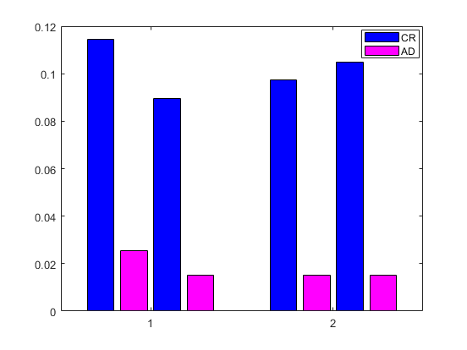

Figure 1: 2 metrics for broadband illumination (BB) and at 550 nm. Contrast Ratio (CR) and Average Deviation (AD) are null for perfectly uniform images.

# Conclusion

Based on the contrast ratio values, the integrating sphere improves the field uniformity for the broadband illumination but not for the 550nm wavelength. Using the Average deviation values, the integrating sphere improves the field uniformity for the broadband illumination as it’s pretty much the same for the 550 nm wavelength. The shutter time is multiplied by 40 to 50 when adding the integrating sphere in the light path.



Figure 2: Img-min(img)